This is the approach companies use to build Kubernetes cluster in production environment. No one has time to build thing manually.

* Skill Involved:

1. Linux skill. Specially SSH configuration and authentication
2. Ansible skill

* Virtual Machine setup needed:

1. Ansible Controller- manish-virtual-machine (192.168.230.130)

OS- Ubuntu 20.04.2 LTS  
RAM – 2 GiB

CPU Core – 1

NIC – NAT

Internal NIC IP: 192.168.230.130

Internet Connectivity

1. Kubernetes Master: master.node1.com

OS- CENTOS 8  
RAM – 4 GiB

CPU Core – 2

NIC – NAT

Internal NIC IP: 192.168.230.128

Internet Connectivity

1. Slave/member node:

OS- CENTOS 8  
RAM – 4 GiB

CPU Core – 2

NIC – NAT

Internal NIC IP: 192.168.230.128

Internet Connectivity

1. OS- CENTOS 8  
   RAM – 4 GiB

CPU Core – 2

NIC – NAT

Internal NIC IP: 192.168.230.128

Internet Connectivity

* **Step-1:**

Check /etc/hosts and hostname.

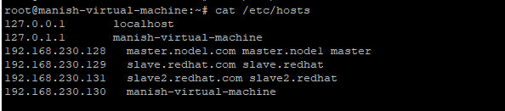

* **Step-2:**

Install epel-release repository on all machines.

# yum install epel-release

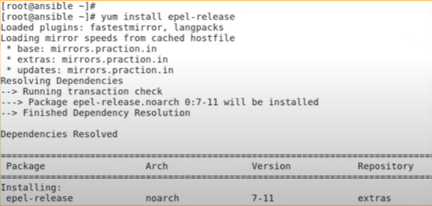

* **Step-3:**

Check connectivity all machines should be able to talk to each other with ip/hostname/fqdn.

* **Step 4:**

We need to install ansible on the controller node.

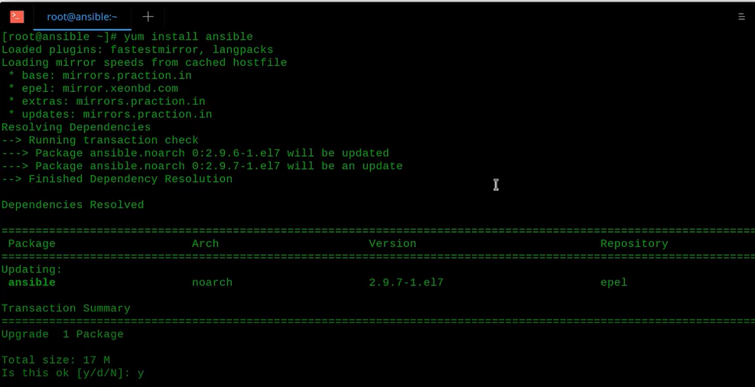

We need to generate a ssh key for making password less connection.

# ssh-keygen

# ssh-copy-id root@machine ip

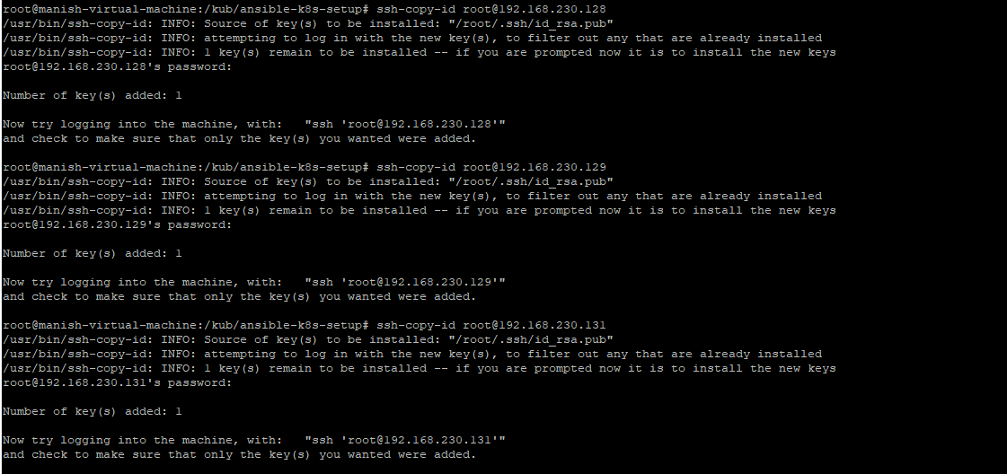

We need to add all the IP (master and slave) into the /etc/ansible/hosts inventory file.

* Step 5:

Create one directory.

# mkdir /kub

# /kub/ansible-k8s-setup

On the controller node install git and download the ansible playbook required for this setup from our git repository

Link: git clone https://github.com/manish392/K8-deloyment-.git

* **Step 6:**

**Edit the host file please define your master and worker node there.**

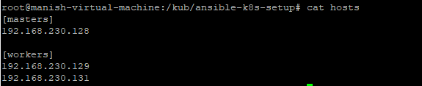

# ansible-playbook k8s-pkg.yml --syntax-check

# ansible-playbook k8s-pkg.yml

# ansible-playbook k8s-master.yml --syntax-check

# ansible-playbook k8s-master.yml

# ansible-playbook k8s-workers.yml --syntax-check

# ansible-playbook k8s-workers.yml

From master node :

To verify :

# kubectl get node

